PLAINTIFF,

IN THE CIRCUIT COURT OF COOK COUNTY, ILLINOIS

COUNTY DEPARTMENT, LAW DIVISION

DEFENDANT,

To:

Plaintiff,

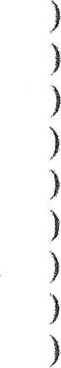Defendant.

NOTICE OF MOTION TO VIA ZOOM PROCEEDING

No.

Please take notice that on , at a.m., or as soon thereafter as counsel may be heard, the undersigned will appear via Zoom before The Honorable Judge and will then and there present the attached MOTION TO , a copy of which is hereby served upon you. To join Zoom, use the following:

Zoom Meeting ID: _____________ Zoom Password: _____________ Telephone: call (312) 626-6799

SIGNATURE OF ATTORNEY

CERTIFICATE OF SERVICE

Under penalties of perjury pursuant to Section 1-109 of the Code of Civil Procedure, the undersigned certifies as aforesaid that this Notice of Motion to and the aforementioned Motion to were caused to be served on all parties of record and on__________ by .

s/ signature

Attorney information Attorney for

Address Phone Email

Attorney number